**Analysis of survey answers given by Information Science experts**

**Statistics – Question 1** 2

*What do you consider to be commonsense knowledge when washing clothes?* 2

**Statistics – Question 2** 4

*What do you consider to be commonsense knowledge when doing dishes?* 4

**Statistics – Question 3** 6

*What do you consider to be commonsense knowledge when vacuuming?* 6

**Statistics – Question 4** 8

*What do you consider to be commonsense knowledge when cooking?* 8

**Statistics – Question 5** 10

*What do you consider to be commonsense knowledge when cleaning windows?* 10

**Average statistics** 12

*Average Gunning Fox Index* 12

# **Statistics – Question 1**

### *What do you consider to be commonsense knowledge when washing clothes?*

Knowing how to sort clothes, what detergent to use and when to apply fabric softener.

Bedienen van wasmachine.

Je moet weten hoe de hele procedure in elkaar zit.

What temperature to use, what colors not to combine.

Washing clothes means they are dirty.

Water is required to clean clothes.

A washing machine can be used to wash clothes.

Do not wash color clothes together with white (light color) clothes.

Do not use high temperature for dark color clothes.

Do not use bleach for clothes of any color other than white.

Use pre-wash cycle for heavily dirty clothes.

different fabrics require to be washed at different temperatures.

Separate colors, keep the temperature low unless there are stains, high temperatures cause colors to fade, the main detergent goes in the largest receptacle.

you need soap and water.

- when clothes come in contact with water, they become wet.

- A too high temperature will damage coloured (mostly cotton) clothes.

- New coloured clothes can release colour and affect other clothes they're washed with.

- Soap is required.

- Conditioner can be used.

- Use spin dryer to make your clothes dry faster.

- Spin dryer can damage delicate clothes.

- Wool stuff shouldn't go in the washing machine.

- Choose the temperature and the time according to the type of clothes you're washing.

used on clothes that are dirty.

typically automated using washing machine, requires electricity.

clothing gets wet.

uses some kind of soap.

machine uses centrifuge to get most of the water out.

takes roughly an hour when using machine.

clothes come out clean, usually.

within certain bounds, higher water temperature washes better.

when water temperature is too high, clothes can shrink permanently.

some dyes (primarily red) can transfer to other clothing items.

clothes can be hung to dry or put in a dryer.

Separate textile types before washing, distinguish in general between high and low temperature washing.

Separate colours, put them in water first and add soap, rinse.

It involves warm water, detergent, clothing, dirt or stains in them. You wash using a laundry machine. It takes electricity to spin the clothing through the warm water, where the detergent dissolved in the water dissolves the stains. The clothes are spun at high speeds at the end of the washing cycle to spin out the water, but the clothes emerge damp from the machine, so you need to dry them out.

Detergent is needed.

Detergent can be in liquid or in powered form.

You can select a temperature and sometimes a program on the washing machine.

You need to check the temperature recommendation on the clothes' labels in order to select right temperature on the machine.

Clothes need to be removed from the machine once washed.

Clothes are washed when dirty, usually with water. Lights apart from Darks. They need to be hanged as soon as possible, otherwise you need to iron.

the laundry will be washed, but comes out wet, and will need to be hung out to dry afterwards

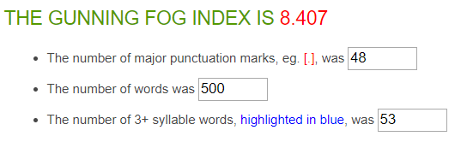

|  |  |
| --- | --- |
| Average Word Length (char) | 5 |
| Average Sentence Length (word) | 9.5 |
| Monosyllabic Words (1 syllable) | 263 |
| Polysyllabic Words (≥3 syllables) | 79 |

**52 sentences in total**

**20 answers in total**

**On average: 2.6 sentences per answer, with a sentence length of 9.5 words per sentence.**

# **Statistics – Question 2**

### *What do you consider to be commonsense knowledge when doing dishes?*

Be hygienic.

Use warm water and soap.

Water is required to clean dished.

You need a sponge, water and soap.

Removing dirt means cleaning.

Use high temperature for greasy dishes.

Soak dishes and pans with thick layers of food, or burned food in the bottom.

Soak dishes and pans with dry/old remaining of food.

the sponge should be clean.

Dry dishes with a tea towel. Rinse very dirty dishes.

you need soap and water.

- you need to close the dishwasher in order to run it.

- Dishes have to be dirty.

- You have to use soap.

- You have to use a sponge or similar.

process to turn dirty dishes into clean dishes.

typically automated using dishwasher, requires electricity.

uses some kind of soap.

dishes get wet.

takes a couple of hours in the machine.

takes roughly an hour when done manually.

dishes come out clean, usually.

within certain bounds, higher water temperature washes better.

when water temperature is too high, some dishes are damaged.

plastic containers may deform when put into the machine.

Rinse before cleaning, handle glass with care.

Keep them in water before washing, use appropriate soap and warm water.

The main methods for doing dishes are either by washing in a sink, or using a dish washer. Both methods involve water, usually warm.

You need a container of warm or hot water (usually a sink). The dishes should be immersed into the water. The surface of the dishes should be in contact with some dishwashing liquid. Usually, this is done by pouring the liquid into the water. You can use either a brush or a sponge to clean the dirt of the dishes.

Stop cleaning the dishes when they are clean. You need something additional than water to wash them.

Dishes are washed when dirty. Water is used.

the dishes are put in water with soap, need drying afterwards.

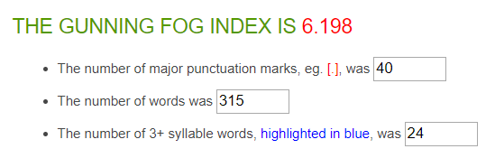

|  |  |
| --- | --- |
| Average Word Length (char) | 4.7 |
| Average Sentence Length (word) | 7.6 |
| Monosyllabic Words (1 syllable) | 169 |
| Polysyllabic Words (≥3 syllables) | 34 |

**41 sentences in total**

**19 answers in total**

**On average: 2.2 sentences per answer, with a sentence length of 7.6 words per sentence.**

# **Statistics – Question 3**

### *What do you consider to be commonsense knowledge when vacuuming?*

Vacuuming allows to remove dirt from the floor.

Empty the dust container for better performance.

Clean the brush for better performance.

the floor should be dry before vacuuming.

Change the socket when moving between rooms. Change the bag when the vacuum cleaner stops working. Remove the vacuum head to clean corners.

you need electricity.

- you should remove small toys from the floor before vacuum-cleaning.

- The vacuum cleaner needs to be plugged to a power socket.

- The vacuum cleaner needs to be on.

- You need to have some dirt on the floor to vacuum.

process to remove dust and other small objects from floor

uses a vacuum cleaner, requires electricity.

uses air suction.

machine only covers a small area of the room; needs to move around.

one or two passes is enough for one spot.

different brushes for flat surface (wood) and bumpy surface (carpet).

Switch device between hard and soft floors .

Remove small objects from the floor.

Vacuuming involves a machine that pulls air through a compartment, trapping the dust and dirt in the air into the compartment. Most vacuum cleaners use a bag for this compartment that will gradually fill up the more vacuuming you do, eventually needing replacement. A vacuum cleaner uses electricity.

A vacuum cleaner needs to be turned on for it to work. You push and pull the long end of the machine over the floor. It sucks up dirt. The dirt ends up in a sac in the machine, which needs to be replaced once in a while when it is full. The machine needs to be turned off when you are done. You should avoid sucking up small items on the floor that are not dirt.

You don't need water for this.

You use a vacuum machine with the sucking part down. At some point you need to clean it otherwise it doesn't suck well anymore.

the vacuum sucks op the dust, it makes noise, it does not work well on liquids, the vacuum is heavy, it does not fit under all furniture, the cable limits its operational radius, the hose can act in surprising ways, the cable rolls up automatically.

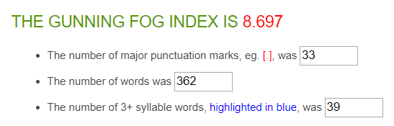

|  |  |
| --- | --- |
| Average Word Length (char) | 4.6 |
| Average Sentence Length (word) | 10.8 |
| Monosyllabic Words (1 syllable) | 228 |
| Polysyllabic Words (≥3 syllables) | 42 |

**33 sentences in total**

**15 answers in total**

**On average: 2.2 sentences per answer, with a sentence length of 11.0 words per sentence.**

# **Statistics – Question 4**

### *What do you consider to be commonsense knowledge when cooking?*

The food has to be cooked (with fresh ingredients) and it has to taste good.

How to use the basics. Cook eggs. Wash your chicken before baking. Dropped food goes into the bin.

If taste is bland, consider adding salt. It enhances flavor.

First, to prevent yourself from getting hurt and after that knowing how to make your food consumable.

Hand niet in het vuur steken, groente snijden.

Juiste ingrediënten.

How to cook in general?

you need some food, recipient (pan, pot) and a source of power (gas, electricity)

cooking requires aggregating and transforming the state of some food.

Usage of each type of pan for each cooking.

Best types of cuts for different cooking.

Taste for salt when the food is not boiling.

tools, pots and pans should be cleaned before cooking.

Fry onions and garlic on a low heat, don't let them brown. Boil water in the kettle before transferring it to a pot. Clean your worksurface as you go.

use one's nose to check the ingredients.

- hot water hurts your skin.

- Fire burns.

- Cooking can smell badly.

- You need some sort of heat source, if you're preparing a cooked dish

process to provide enjoyable food for humans.

humans require food to produce energy/not die.

involves combining edible items.

"cooking" implies that heat was used on at least one of the ingredients.

some ingredients can only be eaten when cooked.

the following can change the resulting dish:

- ingredients used

- amount of each ingredient used

- the shape and size of the ingredients

- order of adding

- combination of steps in the process

- duration of each step in the process.

usually requires:

- pots/pans

- stove/oven

- salt and oil

- meat

- vegetables.

Careful with hot plates and pans, stir fluid products; watch out for heating too long and too much; use water, oil or butter;

Wash fresh products before cooking.

Cooking is the process of heating food to improve its edibility and taste. It often involves pans.

Water in a pan will come to a boil when pan is put on a stove and the stove is turned on. The higher the heat of the stove, the faster the water will come to a boil. If you add food to the water in the pan, the food will soften after some time. Pasta needs to be in boiling water for a predetermined amount of time for it to be edible. The amount of time needed for a particular type of pasta is often listed on the packaging.

You should only cook edible things.

Cooking is a way to make consumables easier to eat and perhaps more tasteful.

You need to the boil water before adding pasta, reduce the gas if it overcooks, cut vegetables with a sharp knife on a wooden/plastic board, removal of certain parts of fruit/vegetables.

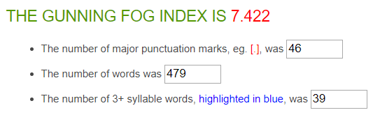

|  |  |
| --- | --- |
| Average Word Length (char) | 4.6 |
| Average Sentence Length (word) | 7.7 |
| Monosyllabic Words (1 syllable) | 284 |
| Polysyllabic Words (≥3 syllables) | 58 |

**61 sentences in total**

**22 answers in total**

**On average: 2.8 sentences per answer, with a sentence length of 7.7 words per sentence.**

# **Statistics – Question 5**

### *What do you consider to be commonsense knowledge when cleaning windows?*

windows can get dirty.

you need wiper and cleaning products.

Start from soaking wet windows.

Concerns for safety.

Drying with paper makes the glass free from stains.

there are specific products fro cleaning windows.

Put soapy water on the windows, scrub and then dry the windows.

you need water and soap.

- you should clean them from both sides.

- Windows are, most of the time, fragile.

process to remove dirt from windows (the ones humans look through, not the software).

typically uses soap and water.

typically done by rubbing the window with soapy water until dirt is gone, then remove access water.

although trivial to automate in isolation, very expensive to automate when windows are part of a building.

Use water, use glass cleaning soap, use whiper for drying.

Remove dust before cleaning, use newspaper foils.

Cleaning windows is usually done using warm water and some kind of detergent. It improves the clarity of the window, which is the main purpose for cleaning it.

You need water and a detergent. You apply the water and the detergent to the window using a tool, usually a sponge or a cloth. Then, you dry the window by 'scraping' off the water with a wiper.

They must be closed otherwise it's dangerous.

You do that when they are dirty. You use water and some tissue at a minimum. Dry them otherwise they get spots.

water runs down to the bottom.

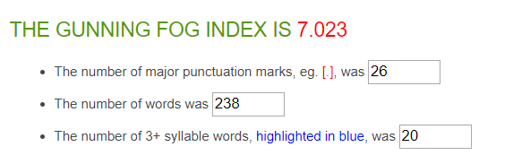

|  |  |
| --- | --- |
| Average Word Length (char) | 4.8 |
| Average Sentence Length (word) | 9.1 |
| Monosyllabic Words (1 syllable) | 129 |
| Polysyllabic Words (≥3 syllables) | 27 |

**26 sentences in total**

**15 answers in total**

**On average: 1.7 sentences per answer, with a sentence length of 9.1 words per sentence.**

# **Average statistics**

### *Average Gunning Fox Index*

(Composed by taking the average of all answers given by Information Science experts)

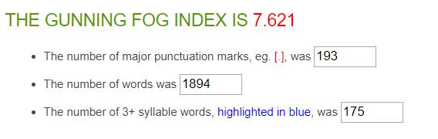

|  |  |
| --- | --- |
| Average Word Length (char) | 4.8 |
| Average Sentence Length (word) | 8.8 |
| Monosyllabic Words (1 syllable) | 1073 |
| Polysyllabic Words (≥3 syllables) | 240 |

**213 sentences in total**

**91 answers in total**

**On average: 2.3 sentences per answer, with a sentence length of 8.8 words per sentence.**